CrossCheck Travel BSP Billing Period and Reconciliation ID Update 2012

Before adding your BSP billing periods for 2012, please log into CrossCheck Travel and check which version you are using, by clicking on ‘Help’ then selecting ‘About’.

If you have CrossCheck Travel Version 3.1, it will look like this:

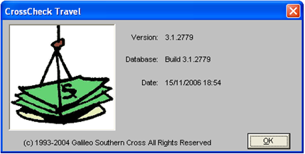

If you have CrossCheck Travel Enterprise, your screen will look like this:

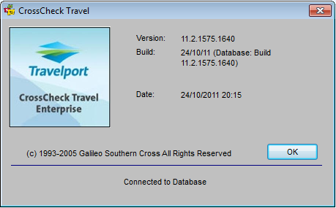

Once you have established which version you have, please ensure all agents in your office are logged out of CrossCheck Travel and then follow these steps to run your update:.

- From the server running your CrossCheck Travel database, please click on the following link which will take you to the Travelport Support Website

- Click on the link BSP 2012 setup

- Click I Agree

- Select the CrossCheck version you are then click on Next

- In the Destination Folder, browse to the default path for Program Files. This will show as C:\Program Files or C:\Program Files (x86) if you have a 64bit machine. Simply click ‘Install’ after adding your default path to continue.

- A backup of your database is then created. Please do not close this screen, as it will automatically close once the backup complete.

- A message will appear once the backup is complete. Click ‘OK’ .

- If you need to restore the backup, it can be found in C:\ date listed in message.

- Once completed, you will see the following message

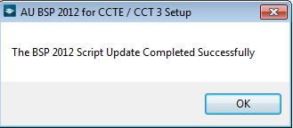

- Click ‘OK’.

- Click ‘Close’ once you see the Installation Complete message.

To check if the update has been completed successfully, CrossCheck Travel Version 3.1 users should go to Options, Tables and then choose Billing Period. CrossCheck Travel Enterprise users should go to Tools, Tables and then choose Billing Period.

In the Year Field dropdown, select 2011. If the periods have been updated, the final period should have a BSP Rec ID listed as 11126.

Common Error Messages

Incorrect version selected

If you choose the incorrect version of CrossCheck Travel, the update will give you an error.
To check, take a copy of the screenshot by pressing CTRL ALT and pasting in an email or word document and then click ‘OK’. You should then check your CrossCheck Travel version. If you believe you have selected the correct version while running the update, please contact the Service Centre on 1300 555 000 (AU) or 0800 425 453 (NZ).

Backup interrupted

If the backup is interrupted during the update, an error message will appear.
If you receive this error, take a copy of the screenshot by pressing CTRL ALT and paste it in an email or Word document and then click ‘OK’. You should then check your CrossCheck Travel version. If you believe you have selected the correct version while running the update, please contact the Service Centre on 1300 555 000 (AU) or 0800 425 453 (NZ).

In both cases, you will need to provide them with the Error Number in the message and advise them of which version you are using.

